#
# 20210329
# I got 200 - OK for this request, but it was not help me, because something was failed on that hosts.

#
# I found names of groups for these hosts here.
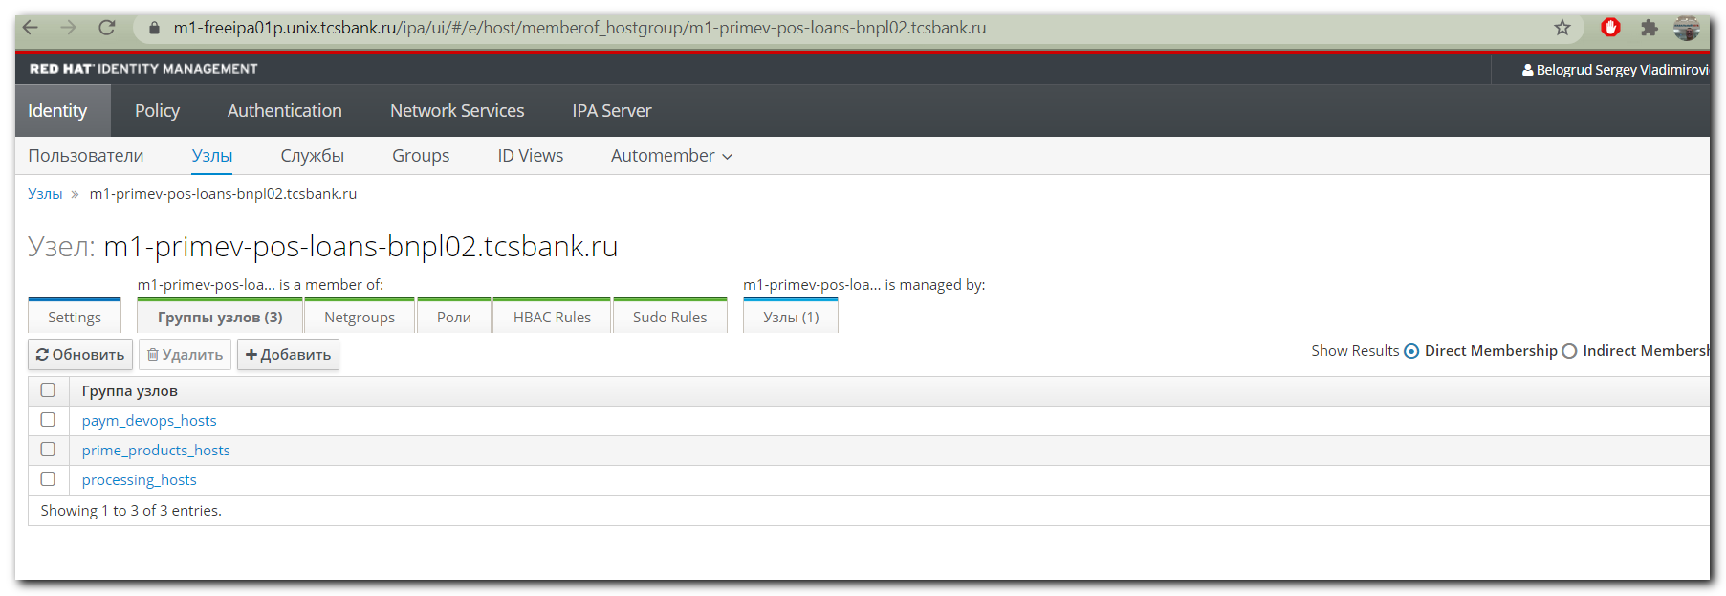

{
"hosts": [
"m1-primev-pos-loans-bnpl02.tcsbank.ru",
"ds-primev-pos-loans-bnpl02.tcsbank.ru"
],
"sudoers": [
"s_s.belogrud"
],
"base_name": "processing_hosts"
}

